PROJECT REPORT
HEALTHCARE COST ANALYSIS
MADE BY - RAVI SHIVDASRAO ANERAO
COURSE- DATA SCIENCE WITH R PROGRAMING
9/20/2021

CONTENT

SL NO | TITLE | PAGE NO
1. | DESCRIPTION | 2
2. | EXPECTED OUTCOME | 3
3. | CODE | 4-5
4. | FUNCTIONS IMPLEMENTED | 6
5. | ANALYSIS | 7-

1 | P a g e

DESCRIPTION
Background and Objective:
A nationwide survey of hospital costs conducted by the US Agency for Healthcare consists of hospital records of inpatient samples. The given data is restricted to the city of Wisconsin and relates to patients in the age group 0-17 years. The agency wants to analyze the data to research on healthcare costs and their utilization.
Domain: Healthcare
Dataset Description:
Here is a detailed description of the given dataset:
Attribute | Description
Age | Age of the patient discharged
Female | A binary variable that indicates if the patient is female
Los | Length of stay in days
Race | Race of the patient (specified numerically)
Totchg | Hospital discharge costs
Aprdrg | All Patient Refined Diagnosis Related Groups

2 | P a g e

ANALYSIS TO BE DONE

- To record the patient statistics, the agency wants to find the age category of people who frequent the hospital and has the maximum expenditure.

- In order of severity of the diagnosis and treatments and to find out the expensive treatments, the agency wants to find the diagnosis related group that has maximum hospitalization and expenditure.

- To make sure that there is no malpractice, the agency needs to analyze if the race of the patient is related to the hospitalization costs.

- To properly utilize the costs, the agency has to analyze the severity of the hospital costs by age and gender for proper allocation of resources.

- Since the length of stay is the crucial factor for inpatients, the agency wants to find if the length of stay can be predicted from age, gender, and race.

- To perform a complete analysis, the agency wants to find the variable that mainly affects the hospital costs.

3 | P a g e

CODE

#importing dataset file
library(readr)
hcare<- read.csv("hospitalcosts.csv")
class(hcare)

summary(hcare)

hist(hcare$AGE, main = "histogram of age freq", xlab= "age group", ylab = "frequency of patients", prob= TRUE, col = "blue")

lines(density(hcare$AGE))

summary(as.factor(hcare$AGE))

x<- aggregate(TOTCHG~AGE, FUN = sum,data = hcare)

x

max(x)

which.max(summary(as.factor(hcare$APRDRG)))
diagnosiscost<-aggregate(TOTCHG~APRDRG,FUN=sum,data=hcare)
diagnosiscost
diagnosiscost [which.max(diagnosiscost$TOTCHG),]

summary(as.factor(hcare$RACE))
head(hcare)
hcare<-na.omit(hcare)
hcare$RACE<-as.factor(hcare$RACE)
mod<-aov(TOTCHG ~ RACE,data=hcare)
mod
summary(mod)
summary(hcare$RACE)

model1<-lm(TOTCHG~AGE+FEMALE,data = hcare)
hcare$FEMALE<-as.factor(hcare$FEMALE)
model1<-lm(TOTCHG~AGE+FEMALE, data = hcare)
summary(model1)
summary(hcare$FEMALE)
head(hcare)

hcare$RACE<-as.factor(hcare$RACE)
model2<-lm(TOTCHG~AGE+FEMALE+RACE,data = hcare)
summary(model2)

model3<-lm(TOTCHG~.,data = hcare)
summary(model3)

4 | P age

FUNCTIONS IMPLEMENTED

- read.csv (): Use the read.csv () function to import data in CSV format. This function has a number
- of arguments, but the only essential argument is file, which specifies the location and filename.

- summary (): Function is a generic function used to produce result summaries of the results of various model fitting functions. It includes: Min. value, 1st Qu. Value, Median value, Mean value, 3rd quartile value, Max value

- hist ():A histogram represents the frequencies of values of a variable bucketed into ranges. Histogram is similar to bar chat but the difference is it groups the values into continuous ranges. Each bar in histogram represents the height of the number of values present in that range.
- R creates histogram using hist() function. This function takes a vector as an input and uses some more parameters to plot histograms.

- lines(): A generic function taking coordinates given in various ways and joining the corresponding points with line segments.

- aggregate(): Aggregate is a function in base R which can, as the name suggests, aggregate the inputted data.frame d.f by applying a function specified by the FUN parameter to each column of sub-data.frame defined by the by input parameter.

- max(): Function in R computes the maximum value of a vector or data frame.

- which.max (): Which.max returns the position of the element with the maximal value in a vector. The value of that element can be found with max (…).

- head(): head() returns the first 6 rows in keeping with the current data.frame convention in R.

- as.factor():This function converts a variable into a factor, but preserves variable and value label
- attributes.

- Aov (): aov() is used to summarize the analysis of variance model. The output includes the columns F value and Pr (>F) corresponding to the p-value of the test.

- na.omit (): The na. omit R function removes all incomplete cases of a data object (typically of a data frame, matrix or vector).

- lm ():It is used to fit linear models. It can be used to carry out regression, single stratum analysis of variance and analysis of covariance (although aov may provide a more convenient interface for these).

6 | P a g e

ANALYSIS

- Record the patient statistics, the agency wants to find the age category of people who frequent the hospital and has the maximum expenditure.

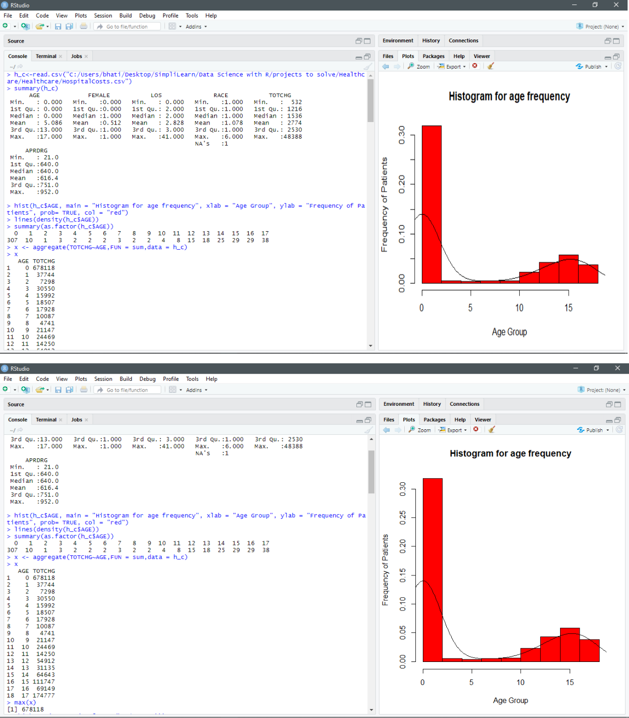

7 | P a g e

After executing histogram, we can analyse that age group with most frequency of patients is: 0-1yrs. Using as.factor () function, allows us to get the count of patients belonging to different age groups. Using aggregate, we can find out the total charges by each age group. To achieve the total amount of

all the people of that age group we provide (fun = sum) in aggregate ( ) function. Hence,
Age group with max visits: 0-1 yrs

Maximum total charges: 678118

- In order of severity of the diagnosis and treatments and to find out the expensive treatments, the agency wants to find the diagnosis related group that has maximum hospitalization and expenditure.

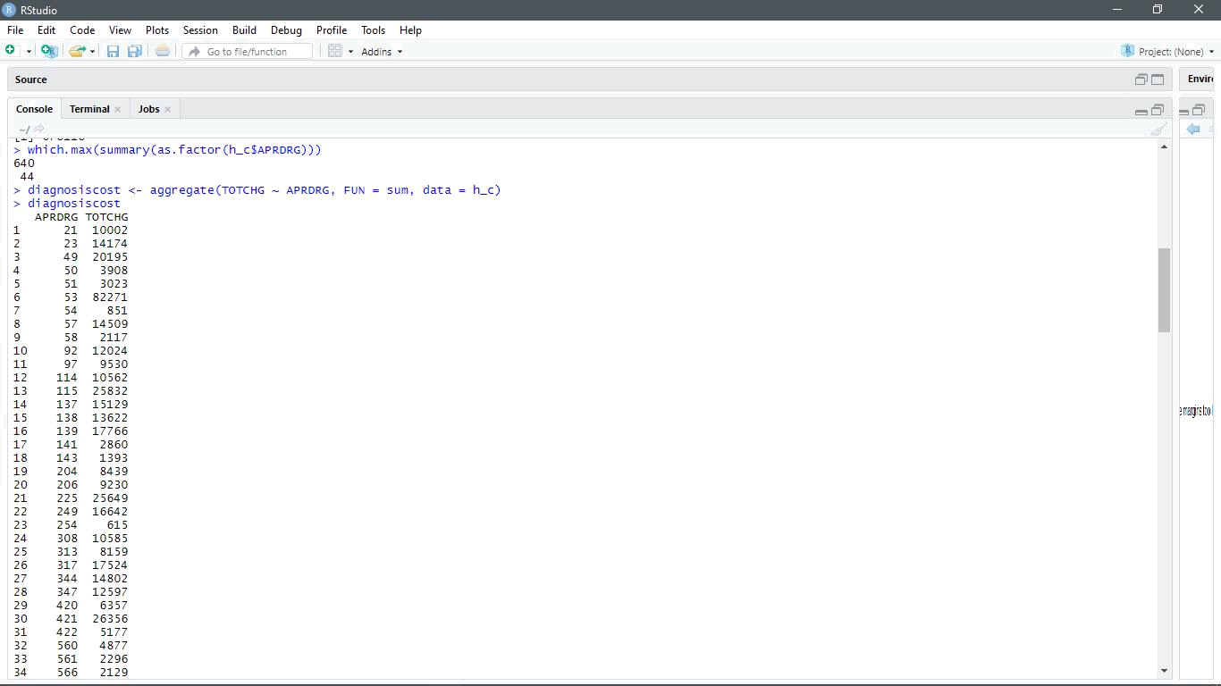

8 | P a g e

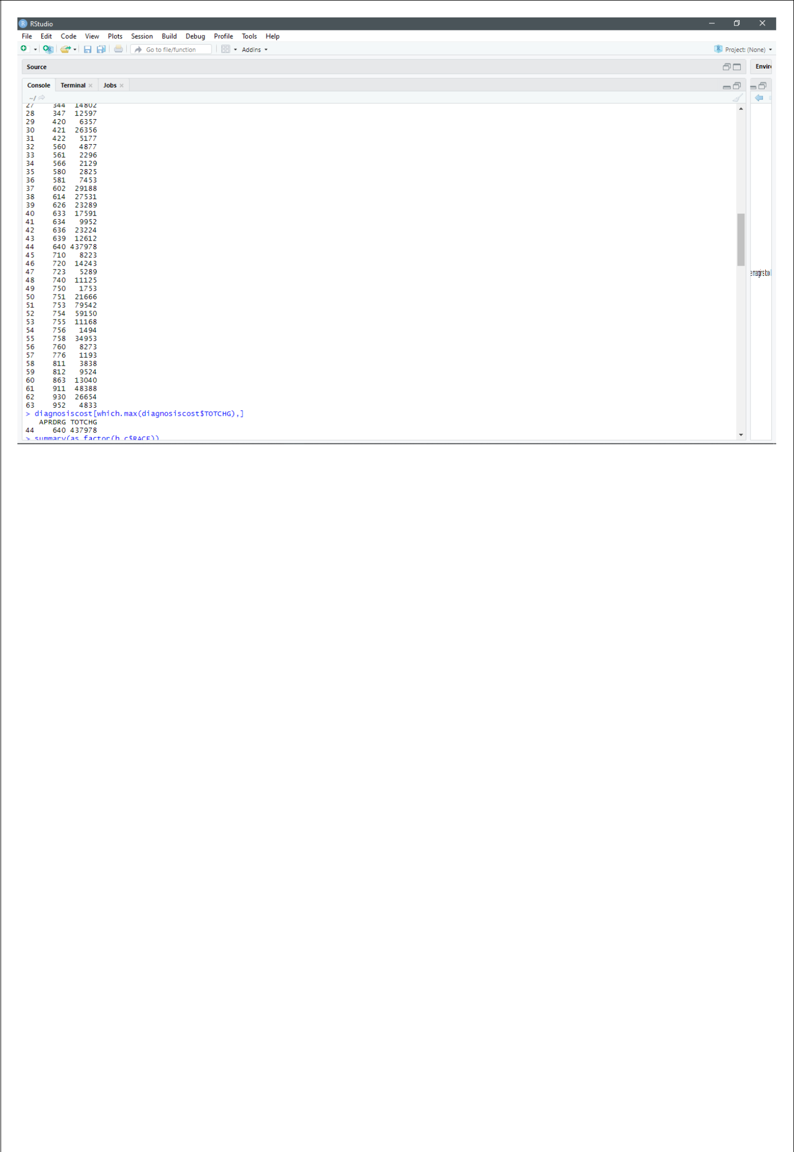

Using which.max( ) we get the elements with the biggest value in the vector. Also to get the total maximum expenditure from all the diaganosis groups we use aggregate() function.

So, diaganosis group with max value : 640

Max expenditure from group 640 is : 437978

9 | P a g e

- To make sure that there is no malpractice, the agency needs to analyze if the race of the patient is related to the hospitalization costs.

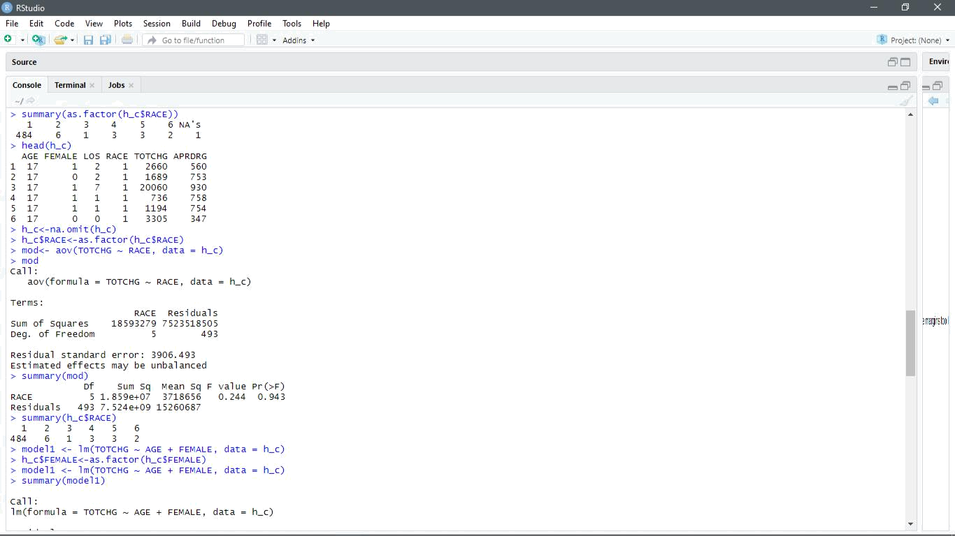

The Residual Value (deviation of the observed value) is very high specifying that there is no relation between the race of patient and the hospital cost.

From the summary we can also see that the data has 484 patients of Race 1 out of the 500 entries.

This will affect the results of ANOVA as well, since the number of observations is very much skewed.

10 | P a g e

- To properly utilize the costs, the agency has to analyze the severity of the hospital costs by age and gender for proper allocation of resources.

To perform this analysis, we use Linear Regression model.

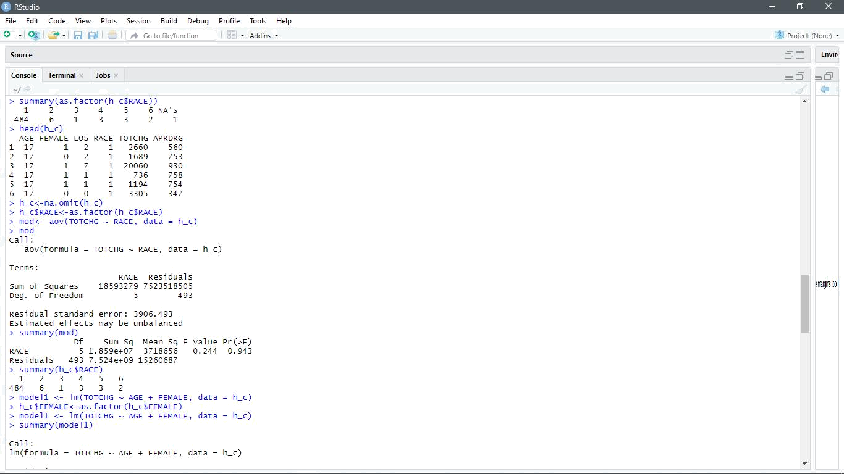

Age is a very important factor in the hospital costs as seen by the significance levels and p-values.

The gender also seems to have an impact.

There is an equal number of male and female patients.

Based the negative coefficient we can conclude that females incur lesser cost than males.

11 | P a g e

- Since the length of stay is the crucial factor for inpatients, the agency wants to find if the length of stay can be predicted from age, gender, and race.
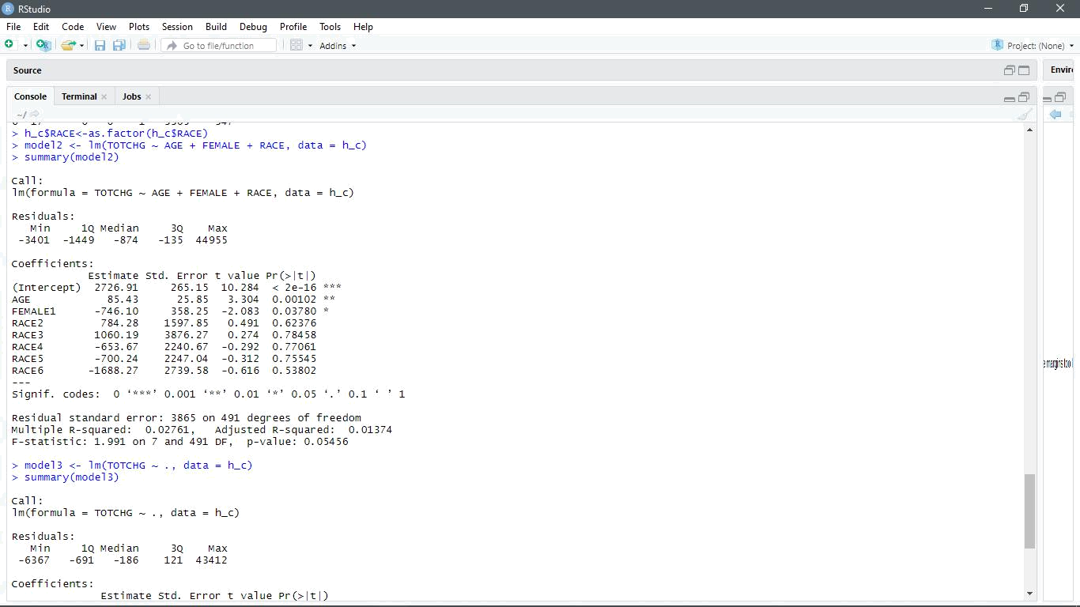

The significance codes are almost null for all the variables, except for the intercept.

The p-value high which signifies that there is no linear relationship between the given variables. Hence we cannot predict the length of stay of the patients based on the age, gender, and race.

12 | P a g e

- To perform a complete analysis, the agency wants to find the variable that mainly affects the hospital costs.

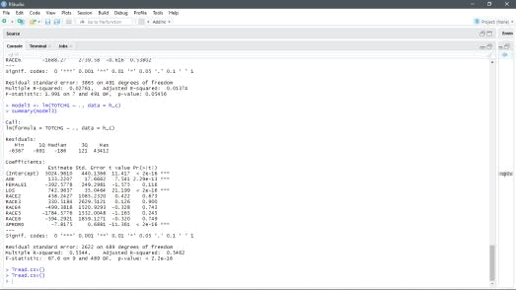

Based on the output we can see that the Age and Length of stay affects the total Hospital cost. Cost is directly proportional to the Length i.e. higher the Length of stay of patients will result to

higher hospital cost.

As per the output we can see that with an increase of 1 day stay, the hospital cost will increase by 742.

13 | P a g e

14 | P a g e

